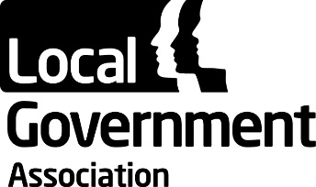

LGA Audit and Risk Assurance Committee Terms of Reference

The LGA’s Audit and Risk Assurance Committee has overall responsibility for monitoring the integrity of the financial statements of the LGA and LGA Group companies under its control, and for overseeing their internal control and risk management systems.

The Audit and Risk Assurance Committee will report annually to the General Assembly on the LGA and LGA Group companies under its control, and to the individual boards on specific issues.

The responsibilities of the Committee are to:

- Review the financial statements prepared for the LGA and LGA Group companies under its control. Specifically, to consider whether appropriate accounting policies have been followed and whether there are concerns arising from the financial statements or from the audit that need to be brought to the attention of the LGA Board or company boards.

- Monitor the processes relating to the management of the LGA’s and each company’s overall risks, internal controls and corporate governance arrangements and consider the level of assurance that can be taken from those processes. Invite risk owners, as deemed necessary, to attend Committee to discuss individual or thematic risks and their mitigation plans.

- Oversee the appointments of the external and internal auditors, checking their independence annually before any engagements, commission work from internal and external audit as appropriate and monitor the operation of internal and external audit processes for the LGA and LGA Group companies under its control. This includes the right of the Committee to meet internal and external auditors without LGA officers being present.

- Consider issues of probity and conduct and agree action necessary to ensure that the practice for the LGA and LGA Group companies under its control reflects an appropriate ethical framework. Receive reports of investigations into complaints received relating to the work of the LGA and against elected members in the course of their LGA business; determine whether any further action is required.

- Seek expert advice where necessary to provide independent internal or external assurance on key issues. Where it is considered by the Chair that across the Committee members there is insufficient accounting and/or control environment knowledge or experience, co-opt a specialist resource to provide additional guidance and insight.

- Present an annual report to the LGA General Assembly, the LGA Board and the individual company boards, detailing the activities of the Committee during the year and an assessment of the adequacy and effectiveness of the internal control framework of the LGA a and LGA Group companies under its control. The Chair to attend LGA Board up to three time per year to present audit reports or the findings of assurance reviews commissioned by the Committee as deemed necessary.

- Carry out an annual review of the effectiveness of the Committee.

Updated September 2023

